EventZ

EventZ is an Event Management app which is been created for the organization. Organization can see upcoming events and register through app easily. It will display details like college fest, cultural shows etc. This is a prototype app which is been created for Schools/University only.

Admin will add information of event through website. We have created a beta version of website and app for admin using Cordova.

For storing data, we have used **Firebase**.

This project has website for admin as well as beta version app for admin. We have not integrated admin part with our main app.

**Highlights of our app: -**

* User can download Brochures and get more details of event.
* Max 15 student can participate per college
* We have integrated UPI payment method to complete payment.

**Number of activity: -**

* Explicit Intent (screen): - Splash, Login, Registration, Dashboard, Booking (Event booking), Payment, Profile, About us(EventZ), Developer info.
* Implicit Intent(screen): - Call us(Contact), Support (Send Email)
* Fragment: - Event Details

**Screenshots**

1. **Splash Activity**

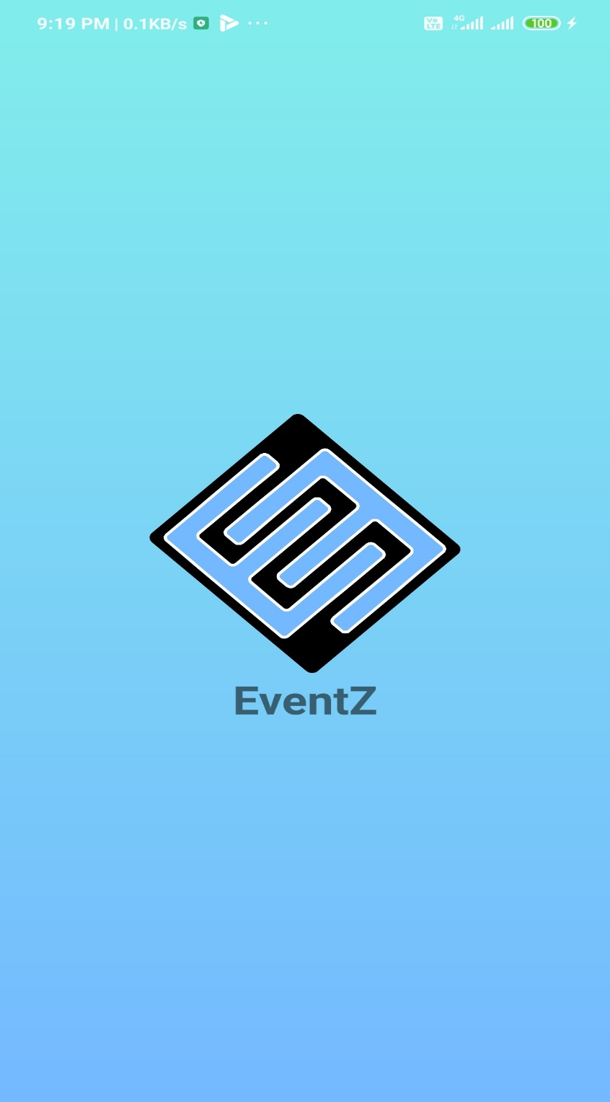

1. **Login Activity**

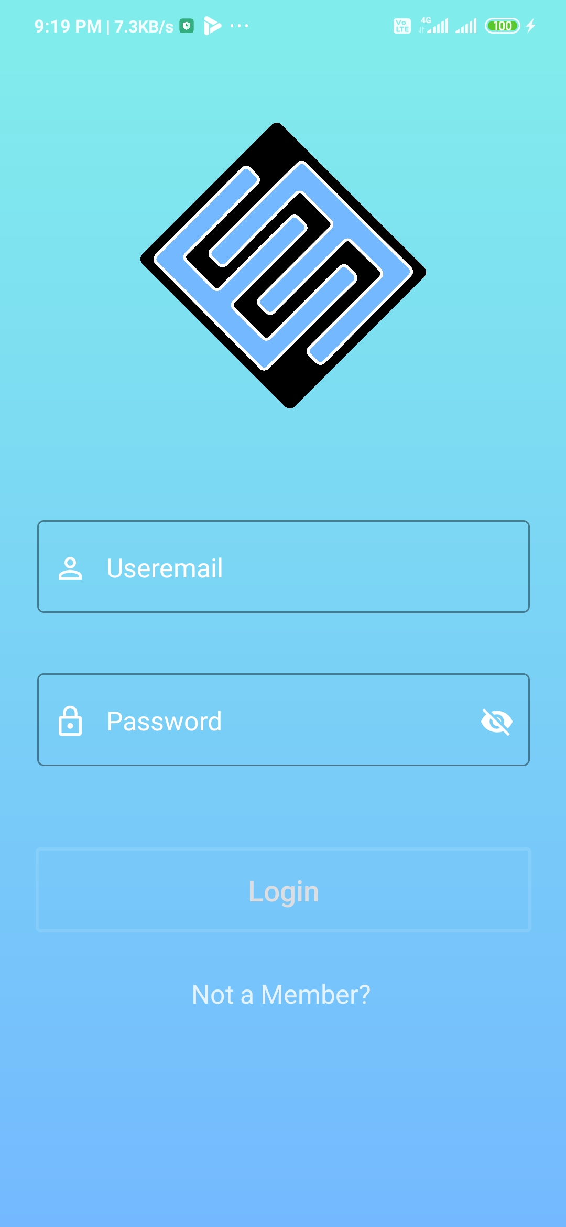

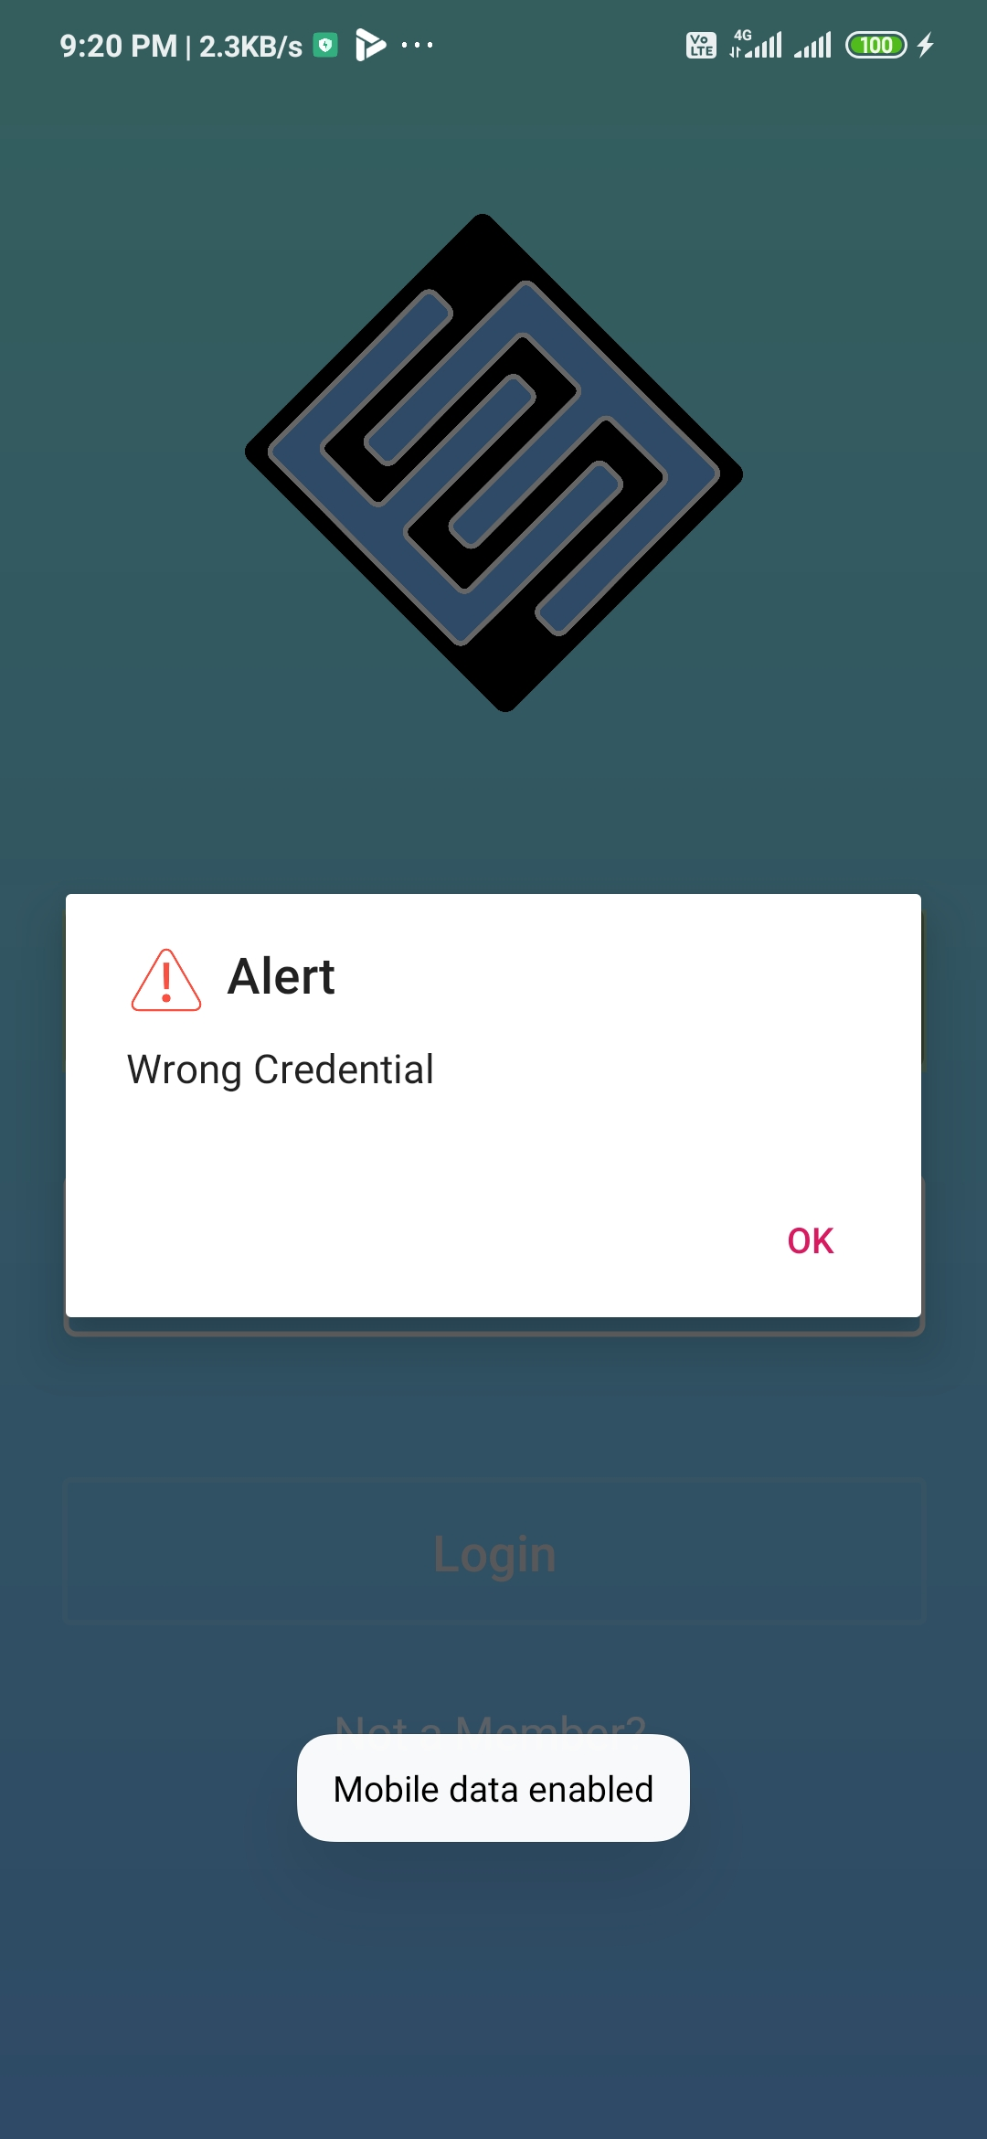

1. **Registration Activity**

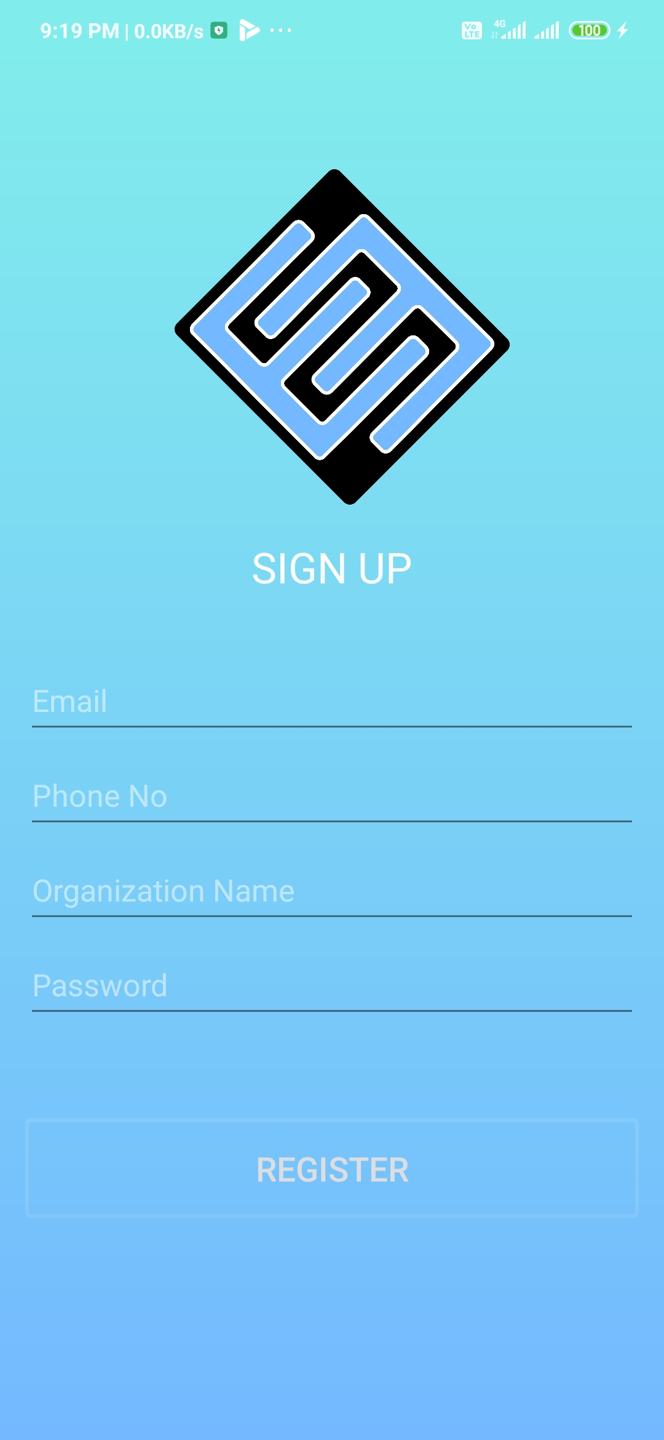

1. **Event Fragment**

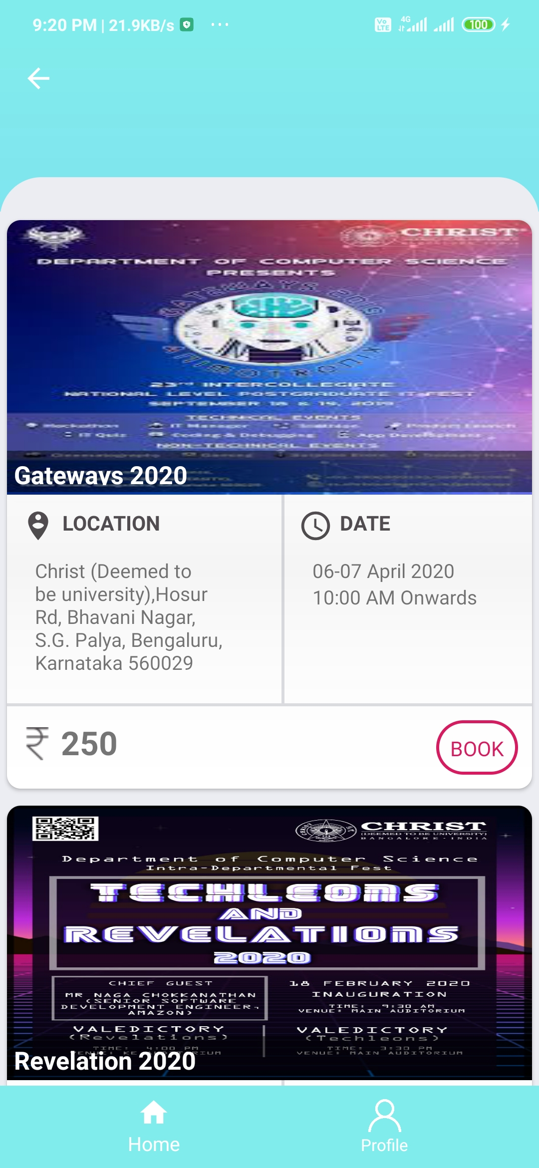

1. **Booking Activity**

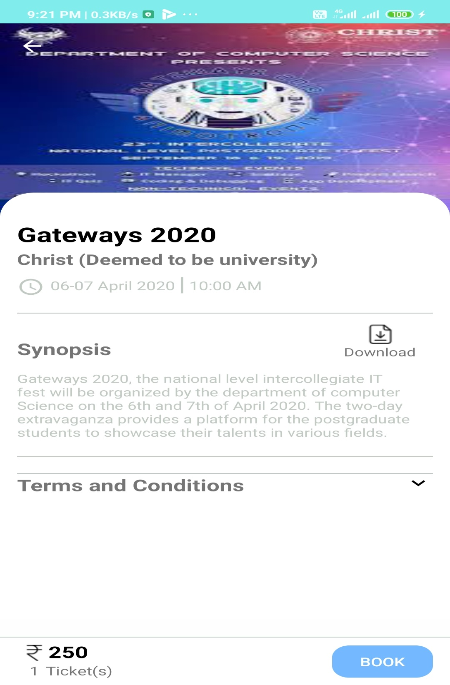

On click of download icon brochures will be downloaded of that event containing details of the event.

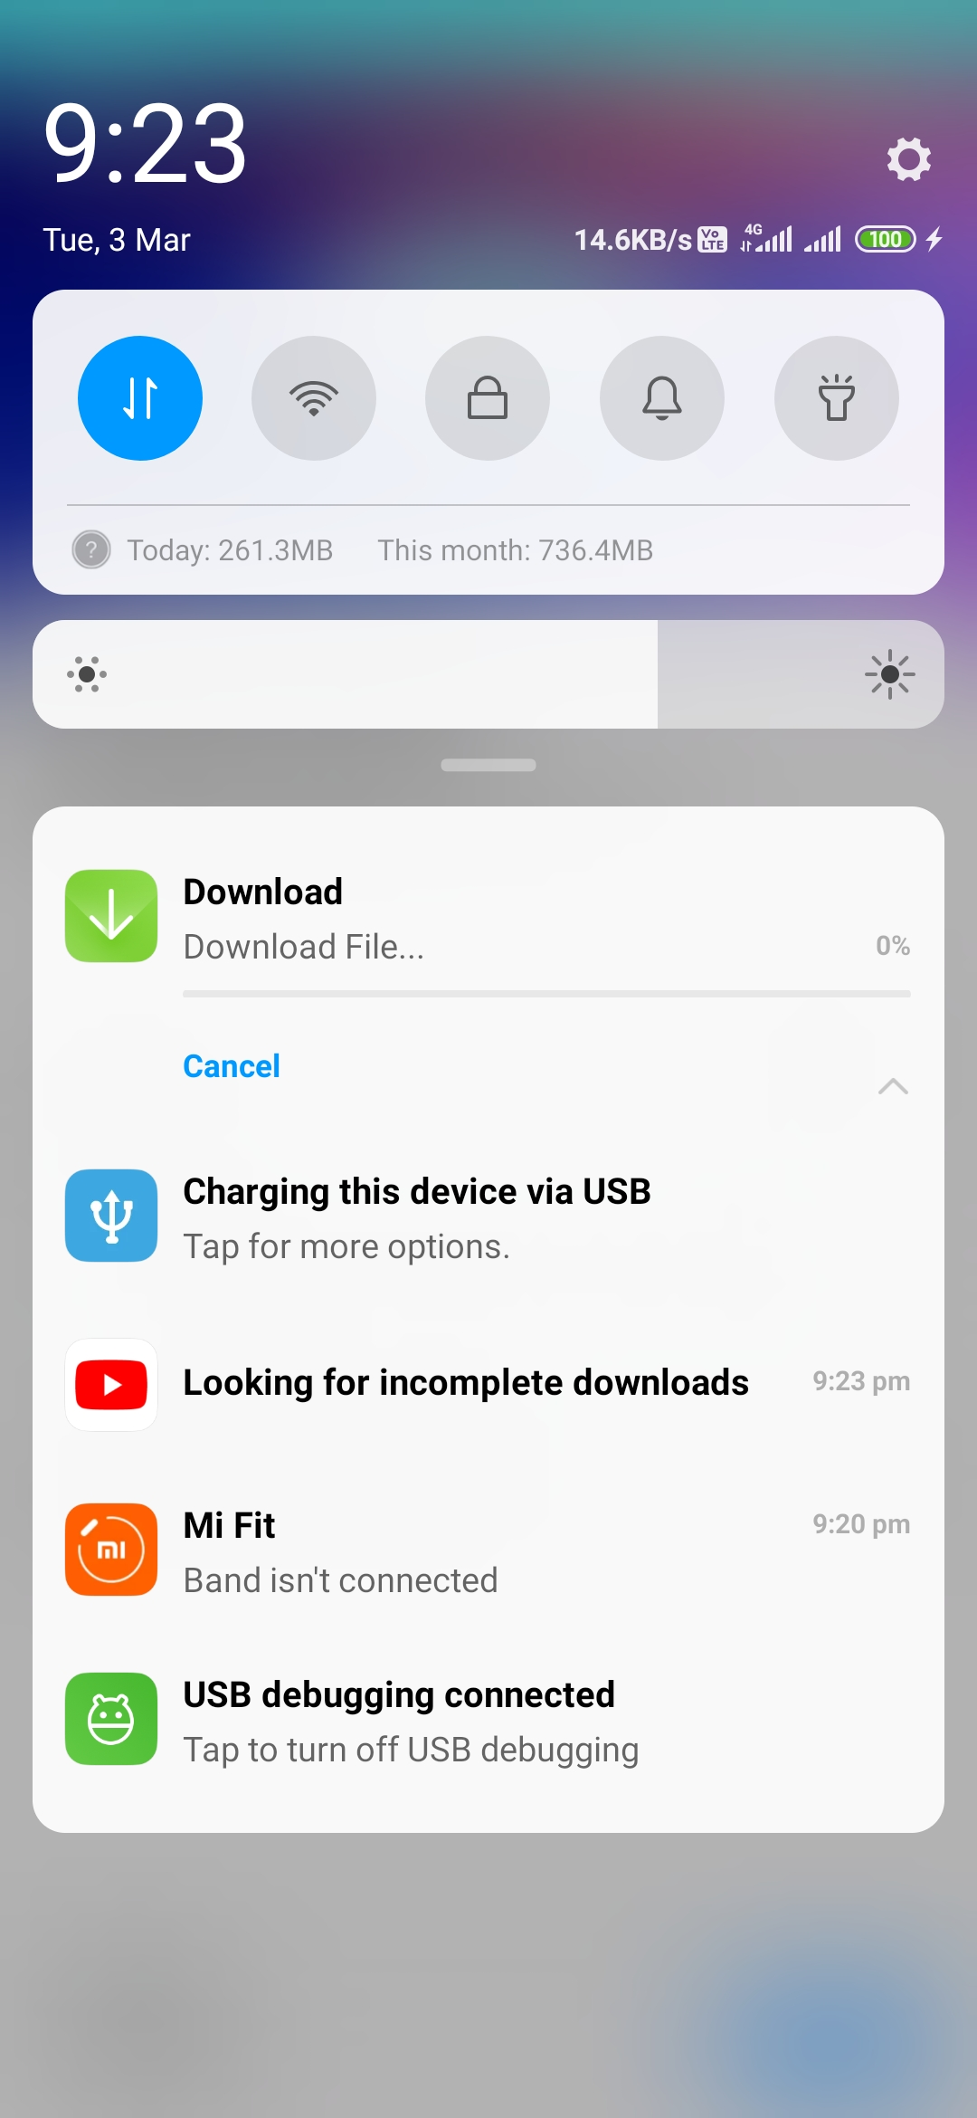

**Downloading file and storing it in device.**

1. **Payment Activity**

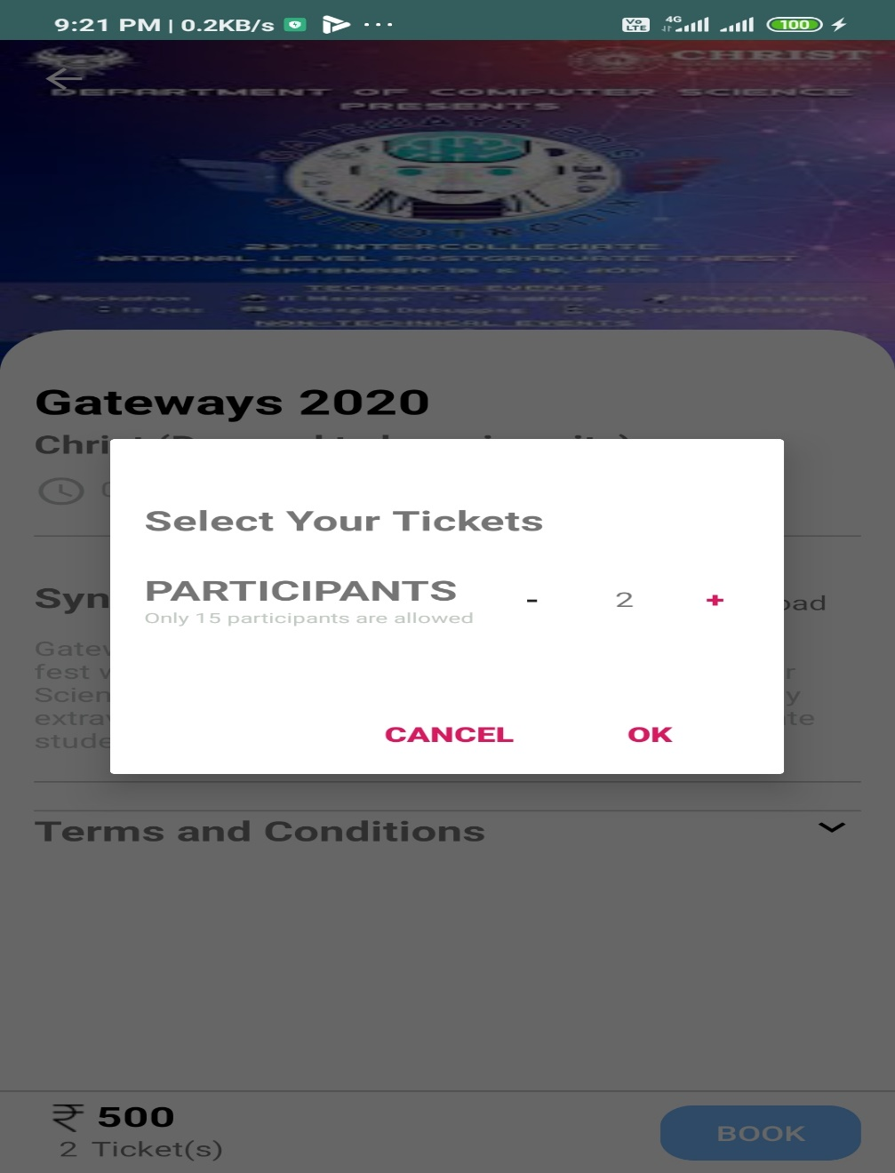

After clicking ok, it will redirect to payment activity.

As of now only 15 participants can take part from one organization.

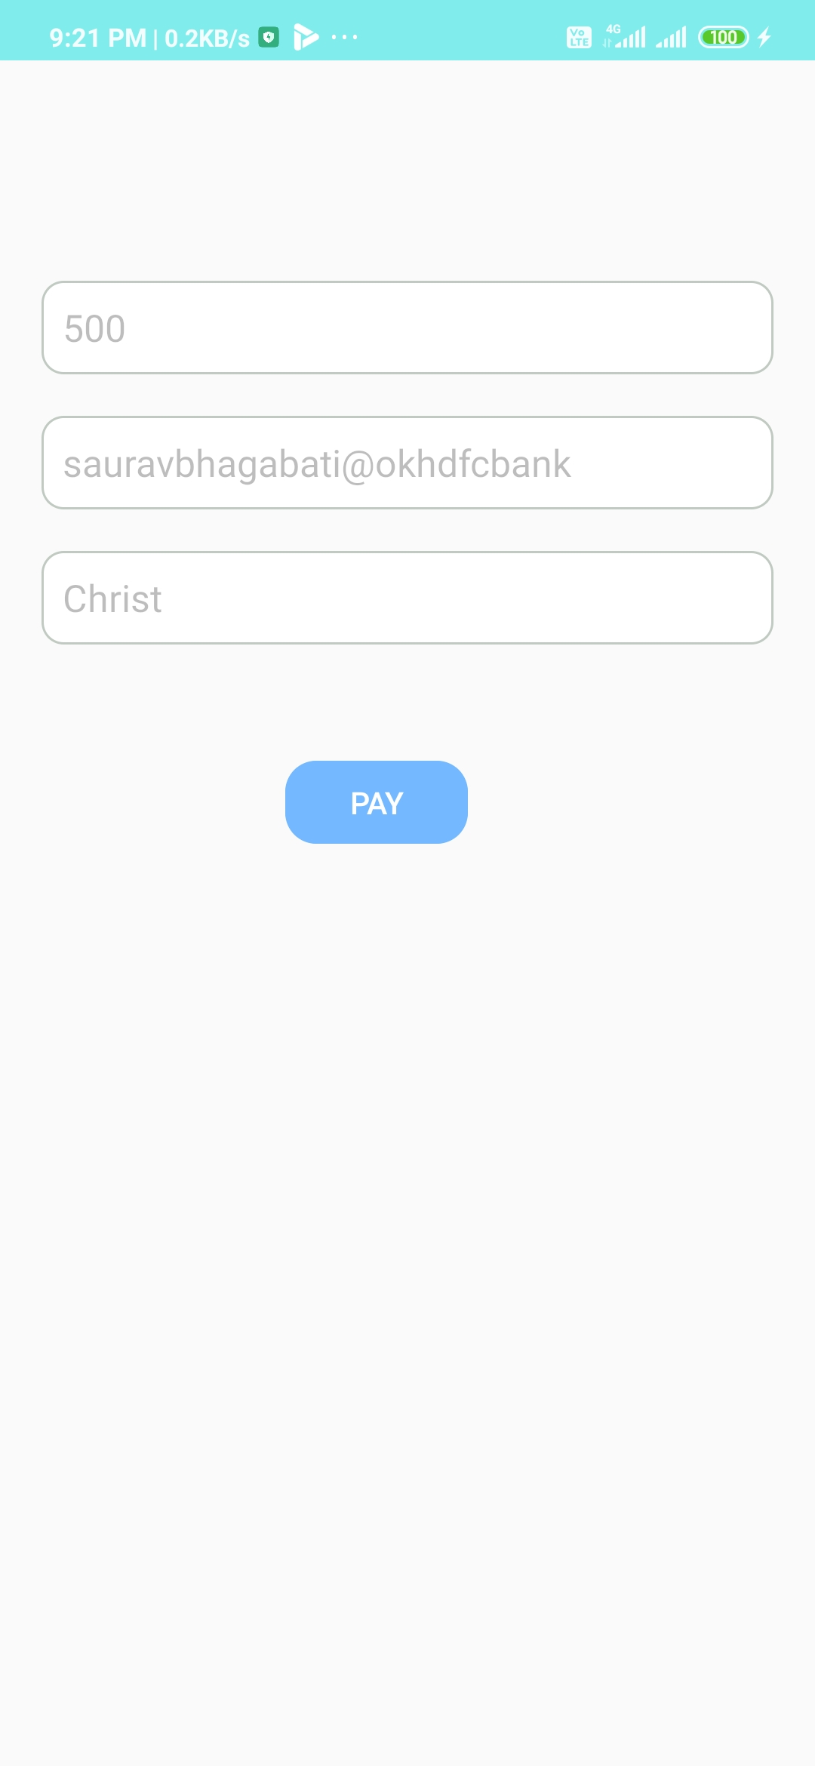

Amount will be calculated and to whom money will be sent and from whom money will be deducted will be displayed here. On click of Pay button it will open various wallet like Paytm, Gpay etc. and this will require permission from user to book.

1. Profile Activity

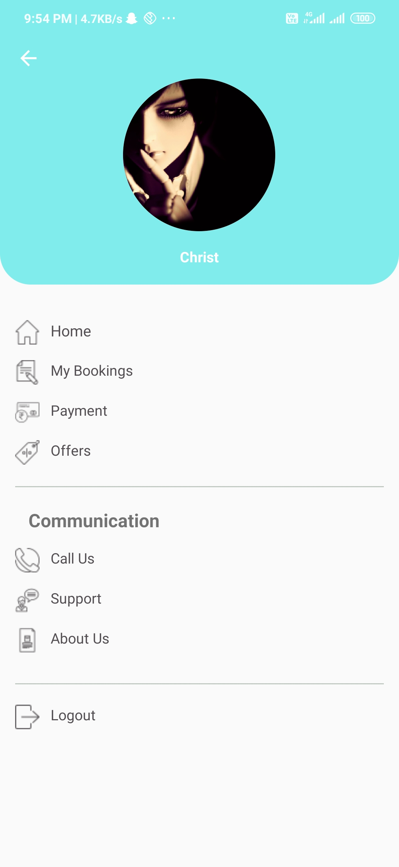

On click of call(Implicit) us it will make a call to EventZ team. And on click of Support it will open Gmail for communication.

1. **About Us**

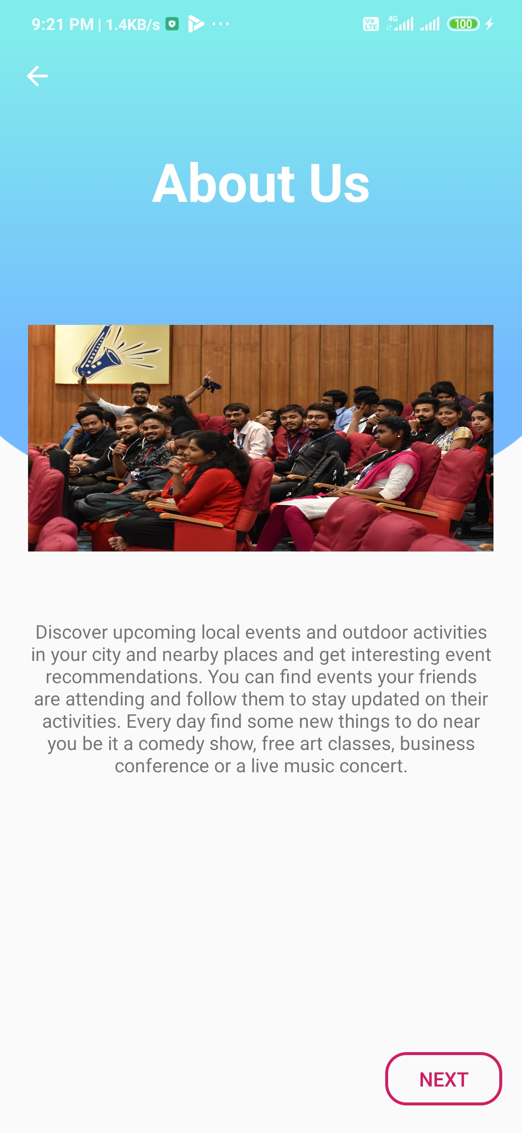

1. **About Us profile**

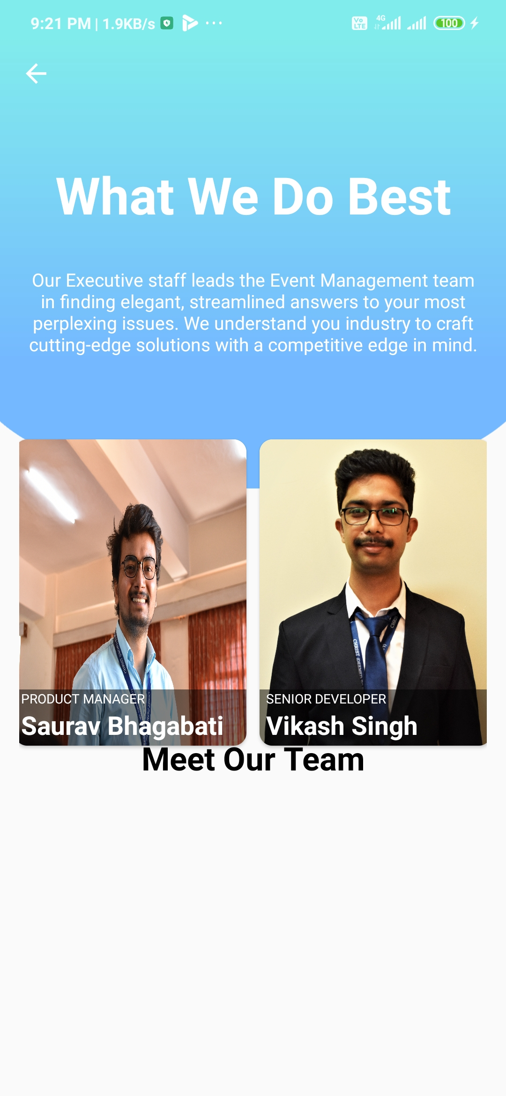

1. **Admin Activity**

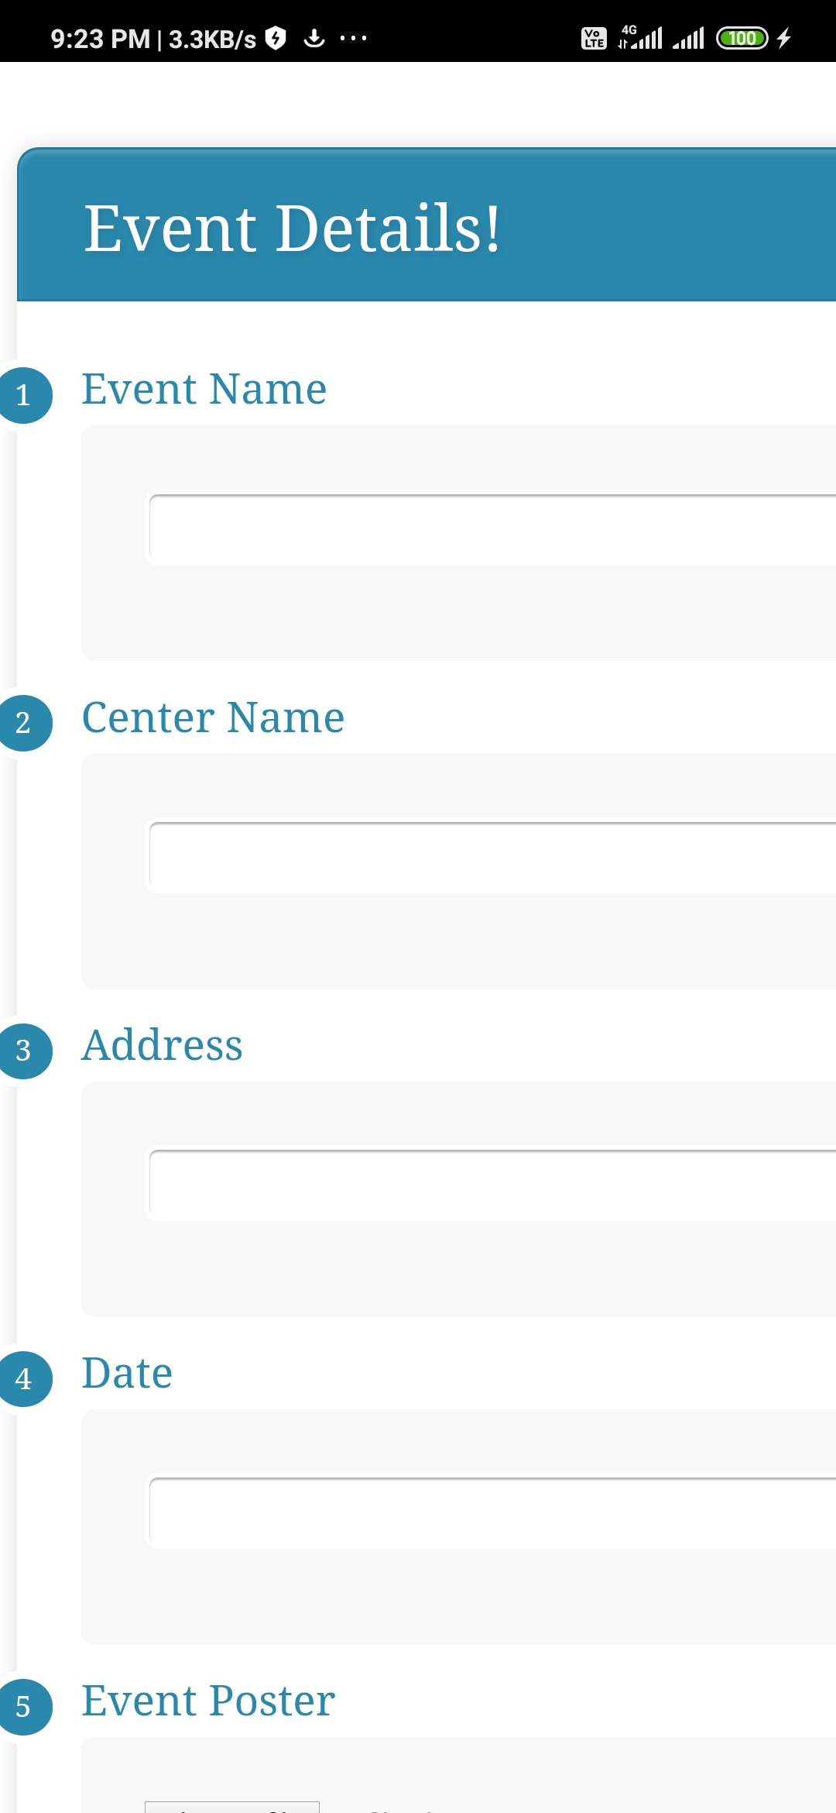

This is an Admin panel for creating event. An organization can upload event through website.

This page is created using HTML, CSS and JAVA SCRIPT and converted this page into app using Cordova.

This is a beta version of Admin and it is not being integrated with our main app.

**Flow of App**

Double tap on the video to play

